Determine o volume do corpo da figura
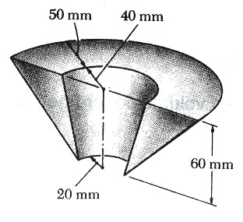
$$\bar{d}$$
C
60mm
20mm
20mm
20mm
50mm
A
B
D
E
$$V=π\bar{d}A_{G}$$
Volume de revolução:

D
E
B
E
B
D

_
=

A
A
A
G
1
2

$$\bar{d}=\frac{\left(\frac{\text{70}}{3}+\text{20}\right)⋅\frac{\text{70}⋅\text{60}}{2}−\left(\frac{\text{20}}{3}+\text{20}\right)⋅\frac{\text{20}⋅\text{60}}{2}}{\frac{\text{50}⋅\text{60}}{2}}=\text{50}\text{mm}$$

$$\begin{aligned}\bar{d}A_{G}={\bar{d}}_{1}A_{1}−{\bar{d}}_{2}A_{2} \\ \bar{d}=\frac{{\bar{d}}_{1}A_{1}−{\bar{d}}_{2}A_{2}}{A_{G}}\end{aligned}$$
Do momento estático ou de 1ª ordem:

Determine A ÁREA DO corpo da figura
$$\bar{d}$$
C
60mm
20mm
20mm
20mm
50mm
$$A_{R}=π\bar{d}L_{G}$$
A
D
E

Áreas de revolução:
D
E
D
E
D
E

+
+
=

G
1
3
2
A
A
A

$$\begin{aligned}\bar{d}L_{G}={\bar{d}}_{1}L_{1}+{\bar{d}}_{2}L_{2}+{\bar{d}}_{3}L_{3} \\ \bar{d}=\frac{{\bar{d}}_{1}L_{1}+{\bar{d}}_{2}L_{2}+{\bar{d}}_{3}L_{3}}{L_{G}}\end{aligned}$$
Do momento estático ou de 1ª ordem:

$$\bar{d}=\frac{\frac{\text{40}+\text{90}}{2}⋅\text{50}+\frac{\text{90}+\text{20}}{2}⋅\sqrt{{\text{70}}^{2}+{\text{60}}^{2}}+\frac{\text{40}+\text{20}}{2}⋅\sqrt{{\text{20}}^{2}+{\text{60}}^{2}}}{\text{50}+\sqrt{{\text{70}}^{2}+{\text{60}}^{2}}+\sqrt{{\text{20}}^{2}+{\text{60}}^{2}}}=\text{49},\text{74}\text{mm}$$

$$A_{R}=π⋅\text{49},\text{74}⋅\left(\text{50}+\sqrt{{\text{70}}^{2}+{\text{60}}^{2}}+\sqrt{{\text{20}}^{2}+{\text{60}}^{2}}\right)=\text{10218},6π{\text{mm}}^{2}$$

$$A=A_{R}+2A =\text{10218},6π+2⋅\frac{\text{50}⋅\text{60}}{2}=\text{35102,7 }{\text{mm}}^{2}$$

